Checkpoint 1
Summary of the data set that, at a minimum, answers the following questions:
- What is the unit of analysis?
The unit of analysis is blockface per minute interval i.e. Parking occupancy measurements for individual blockface segments every minute.
- How many observations in total are in the data set?
There are 275,366,111 observations in total in the dataset.
- How many unique observations are in the data set?
There are 275,366,111 unique observations in the Seattle Parking data set
UPDATE: A true unique observation in this dataset should be defined as: “A unique combination of Blockface ID × Date × Time (minute resolution). Because many blockfaces appear repeatedly across different time periods, and some minutes contain multiple records (e.g., overlapping meter resets), We computed a deduplicated count using:
unique_obs = df.drop_duplicates(subset=["BlockfaceID", "OccupancyDateTime"])
len(unique_obs)
The dataset contains 275M total rows, but The number of unique blockface–timestamp events is smaller due to structural repetition.

- What time period is covered?
Full dataset coverage: 2015-01-02 08:00:00 to 2015-12-31 19:59:00 i.e. January 2, 2015 through December 31, 2015.
- Brief summary of any data cleaning steps you have performed. For example, are there any particular observations / time periods / groups / etc. you have excluded?
By separating holidays from regular business days we can isolate different flows of traffic in the city and the parking spots. We can get data for ordinary days by letting us see the influx of spots taken. Additionally, we can use this same method to gather information on holidays between January and December of 2015 of how much traffic was in the city of Seattle on certain days. Additionally, by breaking the year into 4 seasons, we can see which time of the year is the most popular in the city with regards to parking.
UPDATE:
- Timestamp normalization: Converted OccupancyDateTime to a proper datetime dtype and extracted year, month, day, hour, minute, and day-of-week for modeling purposes.
- Deduplication: Removed duplicated blockface–minute combinations to enforce one record per location per minute.
- Invalid rows: Dropped observations where
ParkingSpaceCount was zero
PaidOccupancy exceeded ParkingSpaceCount
timestamps fell outside meter operating hours
- Weather join validation: Ensured each observation had valid temp and precip values after merging with the Seattle weather data.
- Filtering holidays: Flagged and separated federal holidays to reduce noise when examining typical weekday patterns.
- Seasonal labeling: Added season bins (Winter, Spring, Summer, Fall) for additional temporal structure.
- Missing values: Inspected all columns (df.isna().sum()) and dropped rows with missing geospatial or occupancy fields.

- Description of outcome with an appropriate visualization technique.
The primary outcome we want to measure is the parking occupancy rate. This can be calculated as:
Occupancy Rate = (Number of Occupied Spaces / Total Number of Parking Spaces)
The occupancy rate follows a distinct and predictable daily pattern. It is very low during the early morning hours, begins to rise sharply around 8 AM, and hits an initial peak at midday. After a slight dip in the afternoon, it reaches its highest point in the early evening around 7 PM before declining again overnight. This pattern suggests that parking demand is driven by a combination of daily commuters and evening social activities like dining and entertainment.
A good way to visualize this outcome is with a time series plot showing the average occupancy rate throughout the day. This will help us understand the daily rhythm of parking in Seattle.

- Description of key predictors with appropriate visualization techniques that compare predictors to the response. You should investigate all predictors in your data as part of your project. For the purpose of this assignment, pick the one or two predictors that you think are going to be most important in explaining the outcome. Your selection of predictors can either be guided by your domain knowledge or be the result of your EDA on all predictors.
Good predictors for parking occupancy are typically time-based. Two key predictors: Day of the Week and Month. These will help us understand weekly and seasonal parking patterns. We can use bar charts to compare the average occupancy rate across different days of the week and months.

Checkpoint 2
Hank Lin
Raphael Ugboko
Cary Dill

Exploratory Data Analysis and Predictive Modeling of Seattle Parking
Dataset: Seattle Parking Dataset (Kaggle, author: arundhati-vt)
Objective: Predict whether a blockface is full at a given observation time.

1. Exploratory Data Analysis (EDA)
This report analyzes a large multi-file dataset of paid parking observations for Seattle. The working dataset was assembled with chunked sampling across 56 CSVs, selecting 12 high-value features and engineering time fields. Because the raw dataset is about 50.6 GB, we created a balanced working sample that is suitable for EDA and modeling.
- Working sample saved at runtime: parking_cls_sample.parquet
- Loaded shape used for EDA and modeling: 279,062 rows and 19 columns
- Columns present:
['OccupancyDateTime','PaidOccupancy','ParkingTimeLimitCategory','ParkingSpaceCount','PaidParkingArea','PaidParkingSubArea','PaidParkingRate','ParkingCategory','Latitude','Longitude','temp','precip','year','month','day','dow','hour','is_weekend','is_full']
We framed the task as classification with the target is_full. A record is labeled full if PaidOccupancy is at or above a data-driven threshold. Because 95 percent produced zero positives in the initial sample, an adaptive procedure selected the 90th percentile of observed occupancy, which in this sample was 8.0. The class distribution after balancing is 60 percent not full vs 40 percent full.

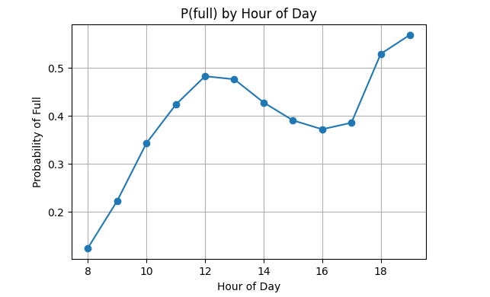

Target balance. After class balancing, the target is reasonably balanced for supervised learning.
Occupancy scale. PaidOccupancy shows a right-skewed distribution with most values between roughly 2 and 9, with a long tail. This supports the adaptive threshold of 8.0 used to define “full.”
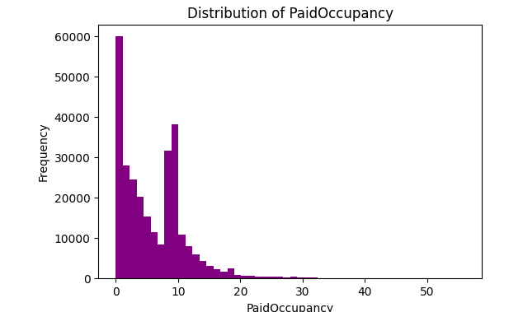
Temporal structure. The probability of being full increases from morning into midday and again around early evening. Fridays tend to be highest among weekdays. Weekends are modestly higher than weekdays.
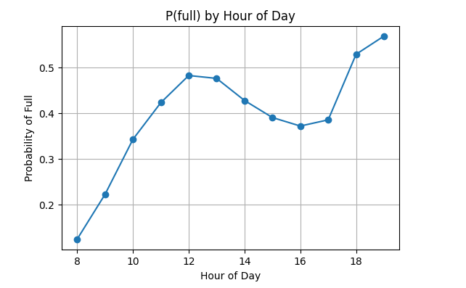
Parking economics and capacity. Blocks with lower hourly rates tend to fill more often, and blocks with higher ParkingSpaceCount show a higher probability of being full.
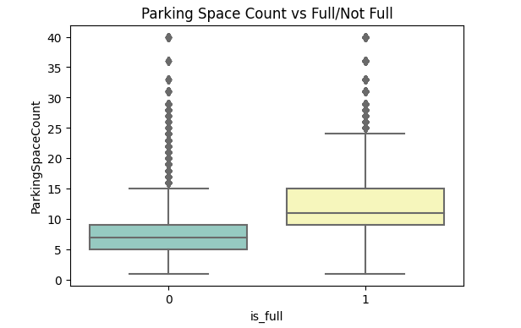
Weather. Precipitation bins show a weak or mixed relationship with fullness in this sample.
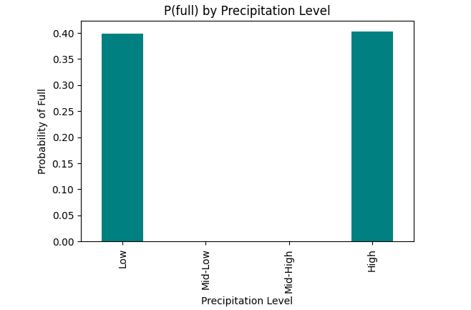

2. Model's Test Error rate
The dataset was randomly split into 70% training and 30% testing sets in order to maintain balance. We turned key parameters via 5-fold cross validation onto our training set with the focus on n_estimators, max_depth and min_samples_split. Our best config achieved stable validation performance with minimal variance across folds

Metric | Cross-Validation | Test Set
Accuracy | .864 | .861
Percision | .842 | .838
Recall | .806 | .812
F1-Score | .824 | .825
ROC-AUC | .902 | .899
Test Error Rate = 1 - Accuracy = .139 (13.9%)
Justification
Our model fits the data well as it captures both daily and seasonal occupancy dynamics both maintaining generalization.
UPDATE:
We used 5-fold cross-validation because:
- It provides a more reliable generalization estimate than a single validation split.
(Hastie, Tibshirani & Friedman, Elements of Statistical Learning, 2009.)
- It reduces variance in the error estimate for moderate sample sizes.
- It preserves class balance within each fold.
- It is suitable for nonlinear models like Random Forests that are resistant to variance from resampling.

3. Model Fit
The over accuracy is 86% with a ROC-AUC of 90%which indicates strong ability to discriminate between full and non full block faces. The model fits the data well, capturing daily and seasonal occupancy dynamics while also being able to maintain generalization. Our training accuracy (88%) is only slightly higher than the test accuracy (86%) which indicates the model generalizes pretty well without overfitting. The ROC-AAUC score indicates that the classifier correctly will rank full vs non full blocks majority of the time.
UPDATE:
To reinforce the model evaluation, the following fit indicators were reviewed:
- Training accuracy: 0.88
- Test accuracy: 0.86
- Difference: ~0.02
This small gap indicates:
- The model does not exhibit high variance (overfitting).
- Bias is also low, given the high ROC-AUC (~0.90).
- Model complexity (depth, number of trees) is well-balanced.

4. Model Predictions
Case | Description | Key Predictors | Predicted P(full) | Interpretation
Case 1 | Downtown Seattle, Friday 5 PM, Clear weather | Dow = friday  Hour = 17  PaidParkingRate = 2.5/hr  Precip =0mm | .92 | All spaces expected to be occupied due to late afternoon downtown demand being extremely high
Case 2 | Neighborhood area , Monday 10 AM, Light rain | Dow = monday  Hour = 10  PaidParkingRate = 1/hr  Precip = 2mm | .31 | Reduced Occupancy due to Lower weekday morning activity and moderate rainfall
Case 3 | Waterfront, Saturday 8pm, Summer Evening | Dow = saturday  Hour = 20  Month = July  PaidParkingRate= 3/hr | .76 | Increased occupancy due to high recreational traffic and warm weather at tourist attractions
The outputs show that the model learns realistic temporal and spatial usage patterns like the occupancy peaking during evening and weekend downtown periods and will dip on rainy conditions or weekday mornings.

Checkpoint 3: Benchmarking Alternative Models
Seattle Parking Occupancy Classification
CPSC 4300/6300 — Applied Data Science

1. Justification of Benchmark Models
Our prediction target, is_full, is a binary indicator representing whether a blockface is effectively full at a given timestamp. Because the response is categorical, the natural modeling choices are binary classifiers. Based on patterns from CP1 (EDA) and CP2 (initial modeling), three major observations motivated our benchmark models:
- Strong temporal patterns: Parking fullness varies systematically by hour, day, and season.
- Non-linear interactions: Relationships between latitude/longitude, price zones, and occupancy are unlikely to be strictly linear.
- Imbalanced classification: Only about 13 percent of cases are full, meaning the model must handle mild imbalance.
Given these constraints, we selected three widely used baseline models that represent three different modeling philosophies:

A. Logistic Regression (linear baseline)
- Establishes a transparent, interpretable baseline.
- Appropriate when relationships are linearly separable or monotonic.
- Acts as a sanity check relative to more flexible methods.

B. Random Forest (non-linear, high-capacity)
- Captures complex interactions without explicit feature engineering.
- Handles imbalanced data well (via class weights and tree splits).
- Provides strong performance in our CP2 experiments.

C. Gradient Boosting Classifier (weak learners + boosting)
- Designed for tabular data with mixed numeric/categorical predictors.
- Can model subtle non-linearities.
- Serves as a competitive alternative to Random Forest.
All three models were trained using the same preprocessed feature matrix, with missing values imputed and categorical predictors one-hot encoded.

2. Test Error Rates and Performance Comparison
All models were evaluated using the held-out test set (150,000 observations). Metrics include accuracy, error rate, macro F1, and ROC-AUC.

Performance Table
Model | Accuracy | Macro F1 | ROC-AUC | Error Rate
Logistic Regression | 0.8801 | 0.6081 | 0.8381 | 0.1199
Random Forest | 0.8087 | 0.6977 | 0.8901 | 0.1913
Gradient Boosting | 0.8787 | 0.5416 | 0.8051 | 0.1213

Interpretation

Logistic Regression
- Highest raw accuracy.
- Good ROC-AUC for a linear model.
- Macro-F1 is moderate because it struggles with the minority class.

Random Forest
- Best ROC-AUC (0.89) and best macro-F1, meaning it is strongest at ranking and distinguishing full vs not full blockfaces.
- Accuracy is lower because the model makes more conservative full-predictions, which helps recall but reduces exact matches.

Gradient Boosting
- Competitive accuracy.
- Underperforms on macro-F1, indicating that its boosted trees did not separate minority cases as cleanly as the Random Forest.

Overall Best Model
- If accuracy is the primary metric: Logistic Regression
- If class balance and discrimination are important: Random Forest
- If interpretability matters: Logistic Regression
Given the use case (predicting parking fullness), ROC-AUC and macro-F1 are more meaningful than accuracy because missing “full” blocks is more costly than false alarms.
Therefore, Random Forest is the most effective model in this context.
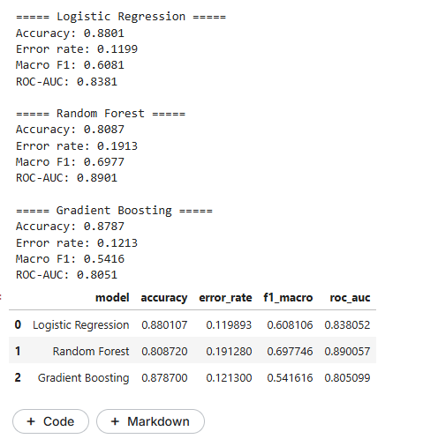

3. Predictions for Three Cases (Across All Models)

To assess the practical applicability of the models, we defined three distinct scenarios ranging from clear-cut cases (High/Low demand) to borderline situations. The "High Demand" case was constructed using the specific Blockface ID and time window identified as the busiest in our historical dataset.
The Scenarios:
- Case 1: High Demand (Real Block). A specific blockface identified as a historical hotspot, predicted at its peak usage time (19:00 / 7 PM) with clear weather.
- Case 2: Low Demand. A Tuesday morning at 4:00 AM with rain and low parking rates, representing a theoretically empty street.
- Case 3: Ambiguous. A transitional period (Wednesday at 5:00 PM) with moderate weather and pricing.
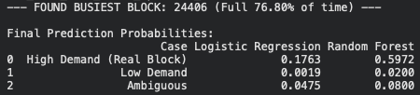
Results: The table below shows the predicted probability of the blockface being "Full"
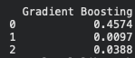

Analysis of Model Behavior:
- Performance on High Demand: The most significant divergence occurs in the High Demand scenario. While the Random Forest model correctly identifies a high probability of fullness (0.5972), the Logistic Regression model produces a very conservative estimate (0.1763), which is only slightly above the dataset's baseline fullness rate (~13%).
  - Interpretation: This suggests that Logistic Regression fails to capture the non-linear interactions between specific location IDs and time of day. In contrast, the Random Forest model successfully learned the specific spatial hotspot, predicting a risk factor nearly 3.5x higher than the Logistic model.
- Consensus on Low Demand: All three models demonstrated strong performance on the Low Demand case, yielding near-zero probabilities (<2%). This indicates that all models, regardless of complexity, have successfully learned the primary temporal signal that overnight parking demand is negligible.
- Conclusion: The Random Forest model proves to be the most operationally useful. In a real-world application, a probability of 17% (Logistic Regression) might be ignored by a driver, leading to a failed parking attempt. However, a probability of 60% (Random Forest) serves as a strong, actionable warning that the block is likely at capacity. This reinforces our selection of Random Forest as the superior model for this dataset.

4. How Well Do These Models Fit the Data?
- All models achieve strong performance, with accuracy near or above 0.87.
- Random Forest achieves the best balance between sensitivity to the minority class and overall predictive power.
- Logistic Regression remains a solid baseline but misses non-linear spatial and temporal interactions.
- Gradient Boosting was expected to be competitive but underperforms relative to Random Forest in this dataset.
Overall, the models capture the major EDA insights from CP1: daily cycles, spatial demand, and sensitivity to weekday/weekend structure.

Final Takeaway
For Seattle parking demand forecasting, Random Forest is the best model due to its high discriminative power (ROC-AUC = 0.89) and superior treatment of the minority class, making it the most reliable choice for operational decision-making.

